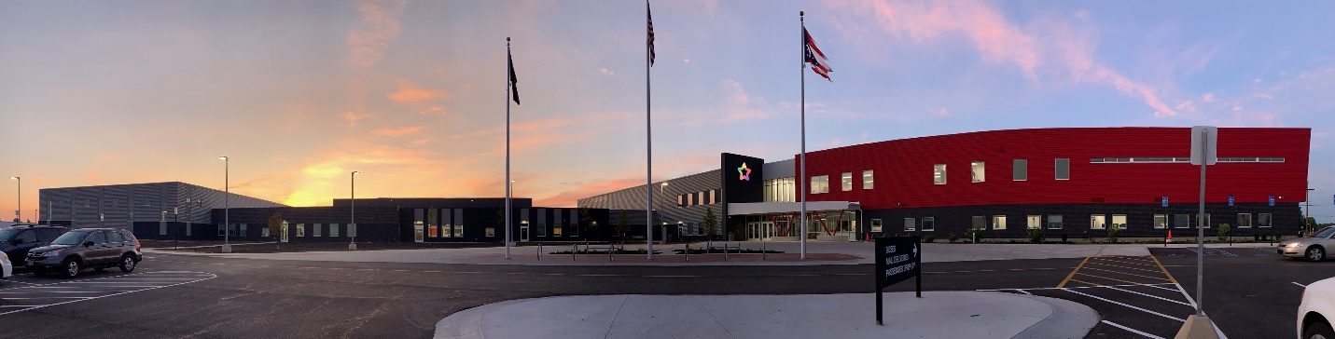
ADULT WELDING PROGRAM AT TRI STAR
7655 St. Rte. 703 Celina, Ohio
www.tristarcareercompact.com
419-586-7060

Fall 2023
Tuesdays and Thursdays 5:00-8:00 p.m. October 3-November 2
$600.00
- Self-paced
- All equipment and materials provided
- Lecture and hands-on
PROGRAM
- BLUEPRINT READING
- WELD NOMENCLATURE
- STICK Welding/mild steel (SMAW)
- MIG Welding/mild steel (GMAW) Flat, Horizontal, Vertical, Overhead
- Safety

First Come, First Served NOTE: class size limited to 10 students
**Steel-toed shoes required
To register, email Marcia Helentjaris marcia.helentjaris@tristarcc.org
Applications available at www.tristarcareercompact.com

